Milestone 5

MyCUPool

Team Members:

Gustav Solis

Michael Whitlock

Sam Bennetts

Yi Wu

Yuxuan Luo

Zhiren Chen

User Acceptance Tests:

The goal of user acceptance testing is to make sure that our web app matches user expectations.

UAT #1: **User can access the SignUp page and LogIn page.**

In this test, what we need is users are able to open the signup and login page. The test would be complete once the login and signup pages show up.

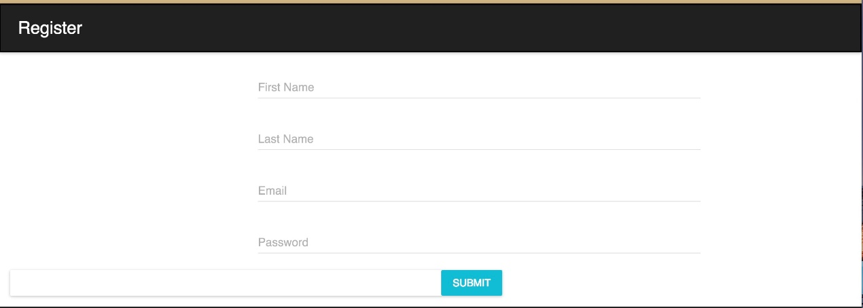

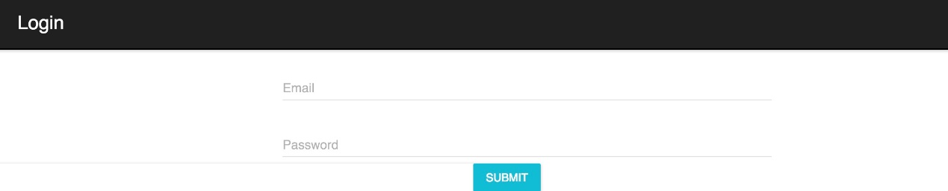

UAT #2: **User can create an account through the SignUp page, only if they input correct format of Email address.**

This test case would help users to create their account. Users can do the signup by entering their name, email address and password. If the email address was used before (That means this email address is already in the database), there will be an alert says: “ Fail to Signup”. If the user enters a invalid email address, another alert will be showed and says: “Need valid email address!”. Once the user enters a valid Email address, they will create an account, and after click the “submit” button, there will be a alert says: “Successfully Registered!”.

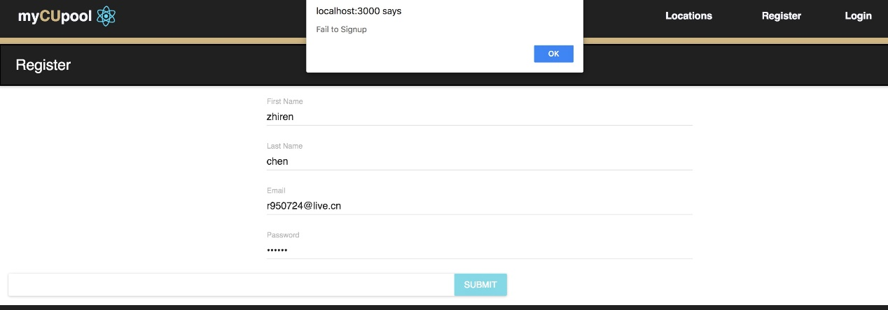

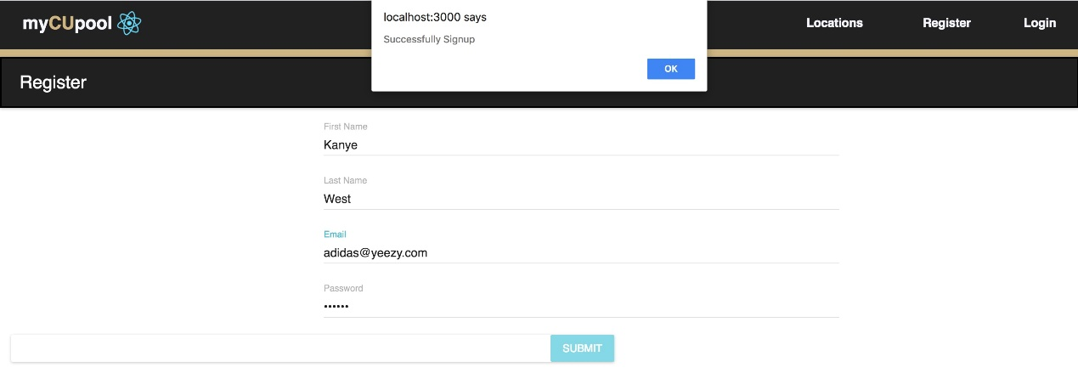

UAT #3: **Users will be redirected to the profile page after they login.**

After user enters a valid email address and a correct password, he/she will be redirected to the profile page, which shows all the user’s information.

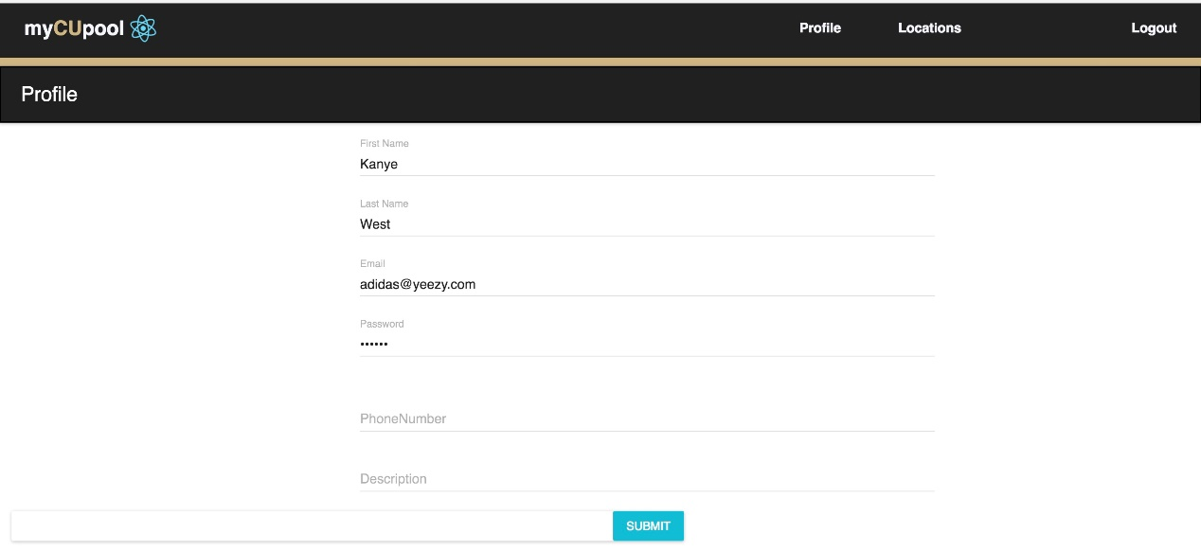

UAT #4: **Users can update their information through the profile page.**

In the profile page, users can change their password and personal information. They will also be able to add their phone number and personal description. After updating information, the website will show an alert says: “Successfully Updated!”.

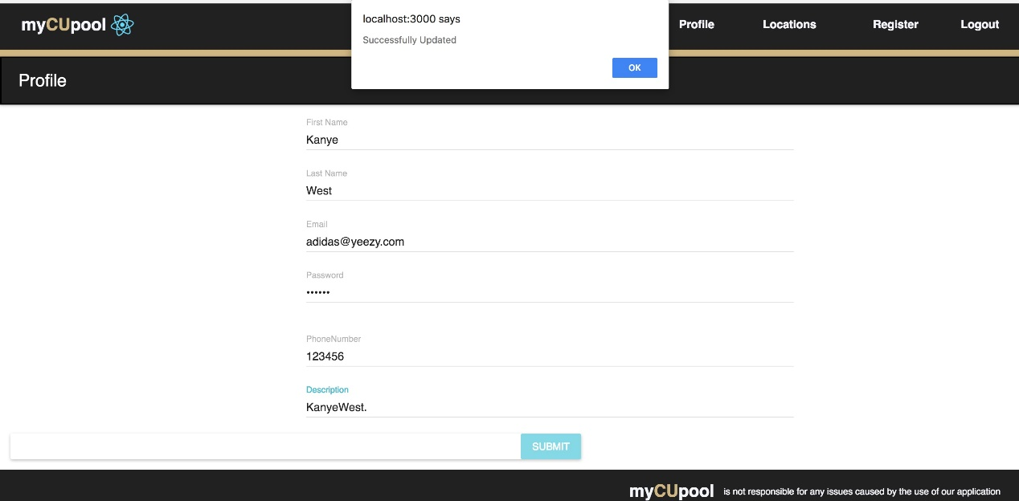

Automated Testing:

The goal of automated testing is to make sure our app is working fine and if there is any error, we’ll throw/fix them.

**(We decided to make an appointment with our TA, to demonstrate our automated tests)**

Automated Test #1: **The database testing(MySql).[TOOL: MySql Command Client]**

In this test case, we wrote some code that contains some incorrect MySql queries, and by putting these queries into our userlogin database, we received some error returns for the incorrect queries and we also received some passed returned for those correct queries.

The test query:

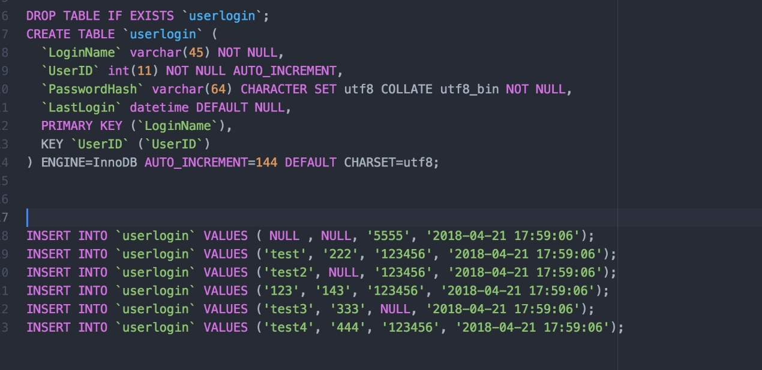

Console logs from MySql:

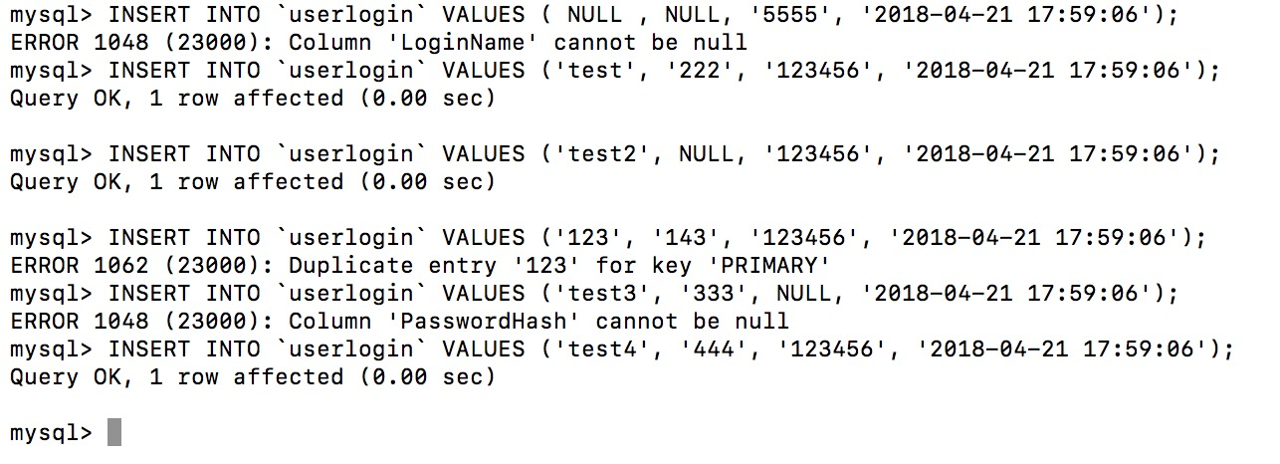

Automated Test #2: **The program testing(MySql).[TOOL: React.js and Express.js]**

In this test case, we are testing the database’s responses. We are sending requests and data from frontend to backend, and by observing the console logs, we found some incorrect statement in our code(/server/controller/userinfo.js):

The errors in backend:

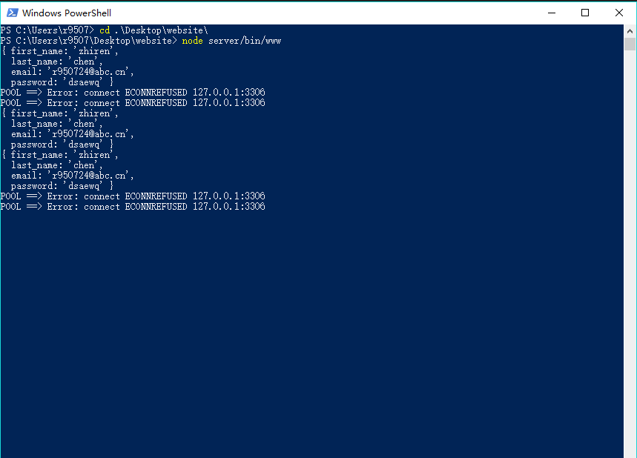

Incorrect statement was found:

